**1)Install git.**

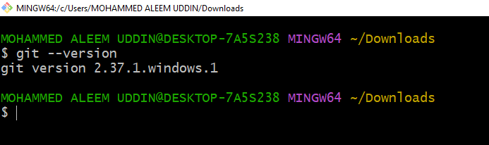

**2)Create a repo in github with README.md and .ignore file.**

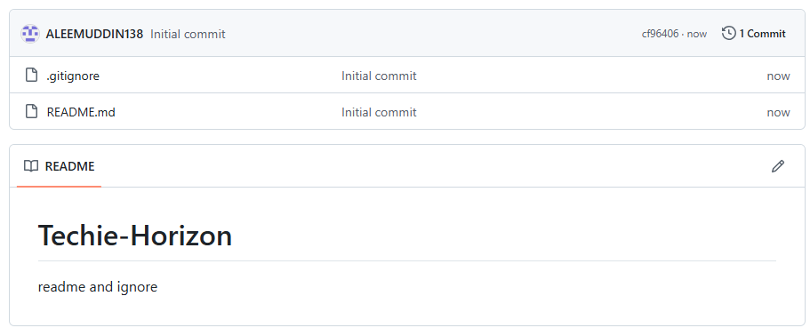

**3)Clone the created repo to local.**

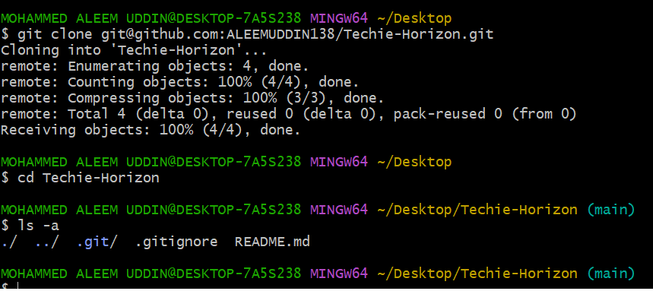

**4)Create two files in local repo.**

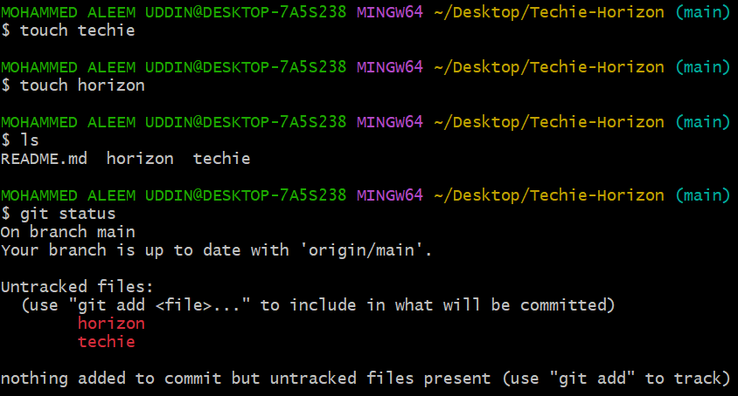

**5)Commit two files and push to central Repository.**

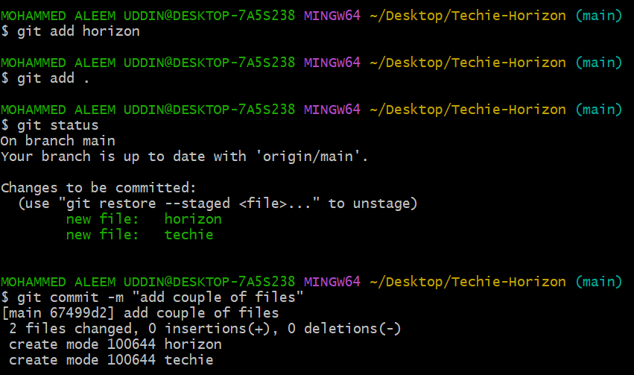

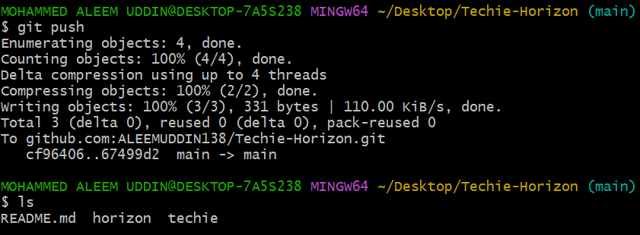

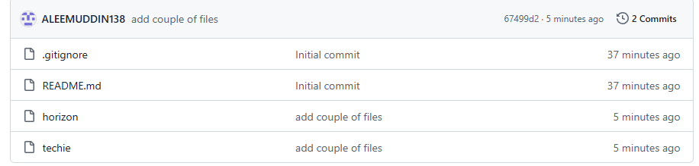

**6) Create a branch in local and create a sample file and push to central.**

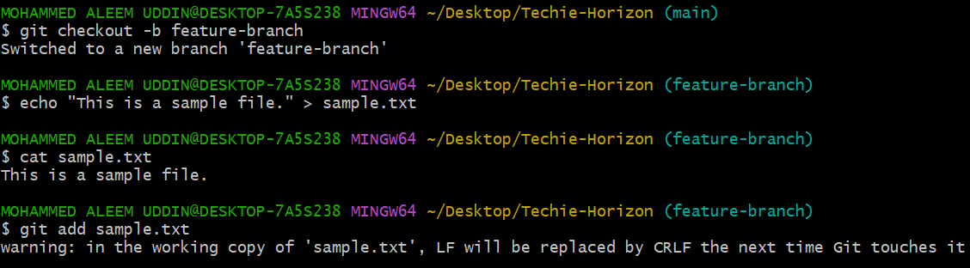

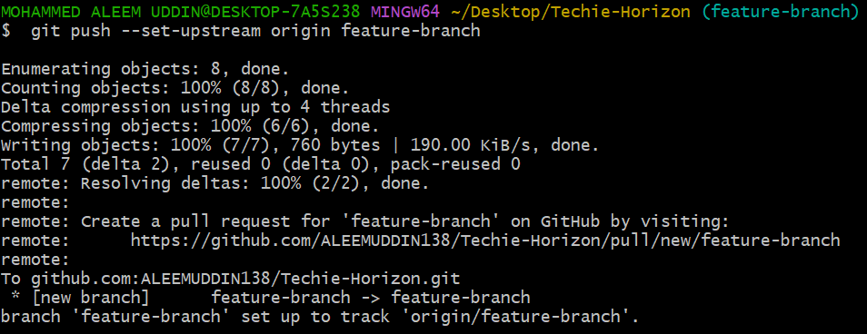

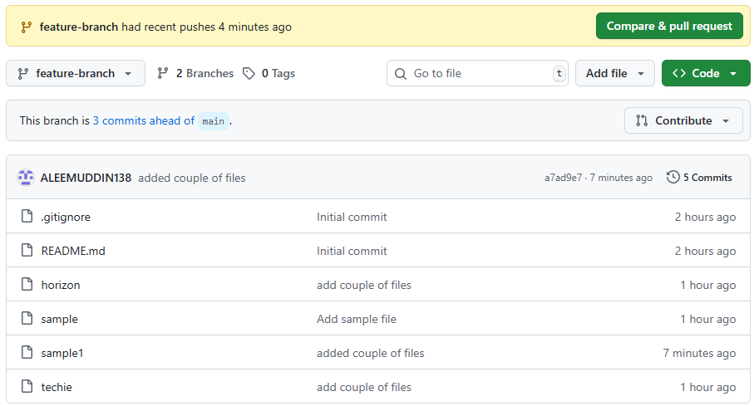

**7) Create a branch in github and clone that to local.**

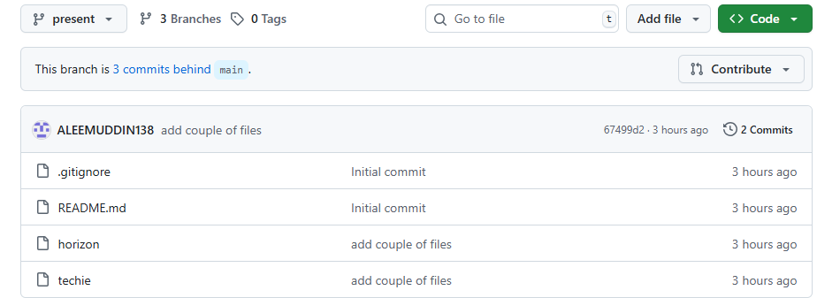

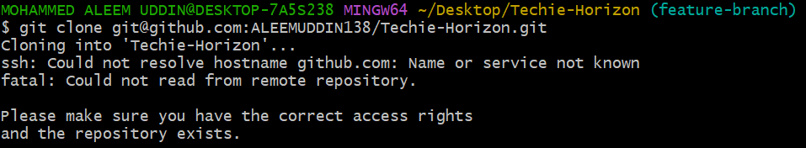

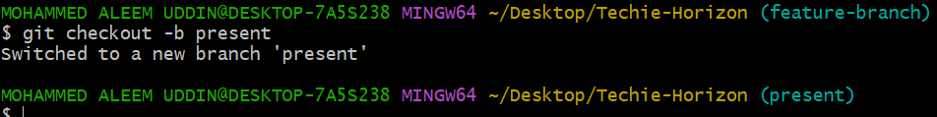

**8) Merge the created branch with master in git local.**

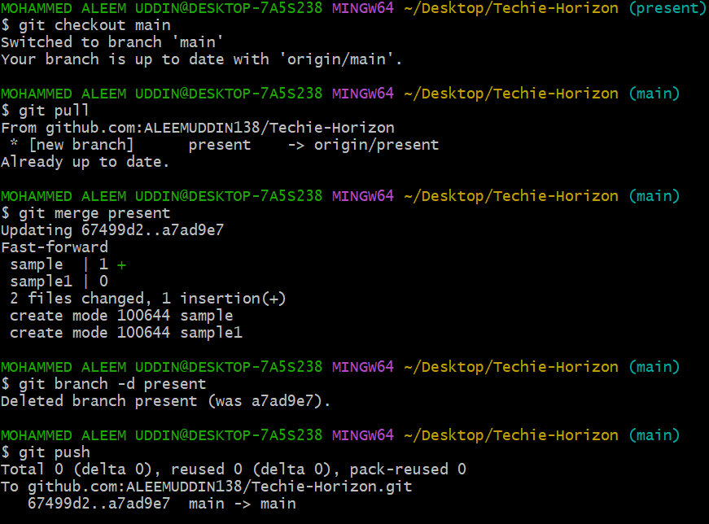

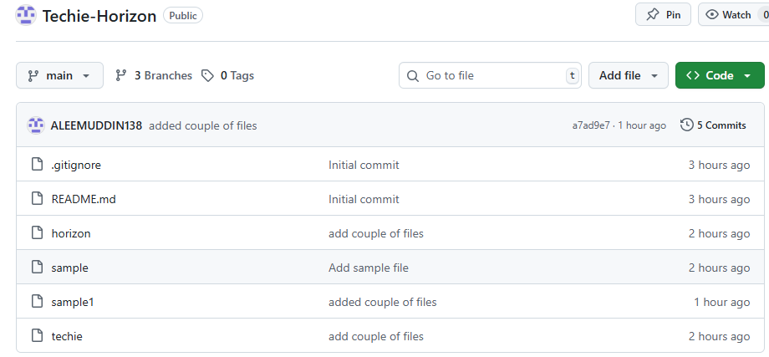

**9) Merge the created branch with master in github by sending a pull request.**

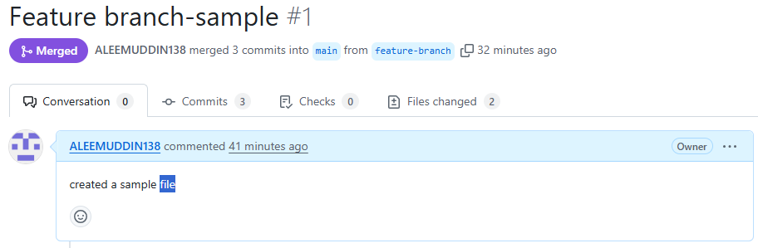

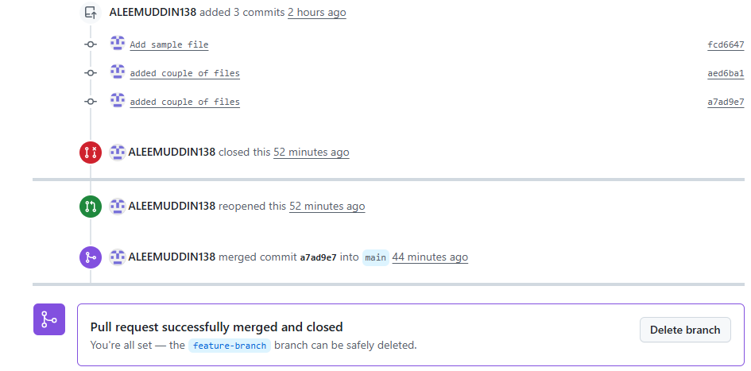



**10) Create a file in local and send that to branch in github.**

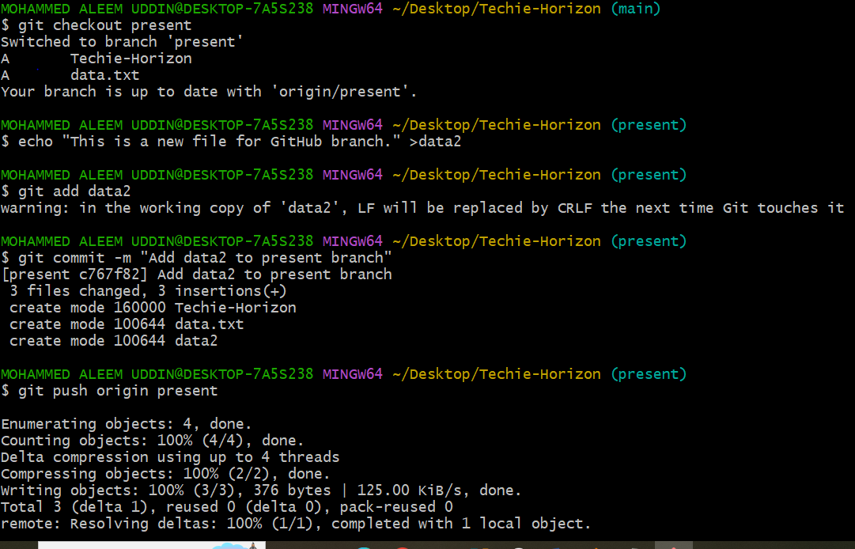

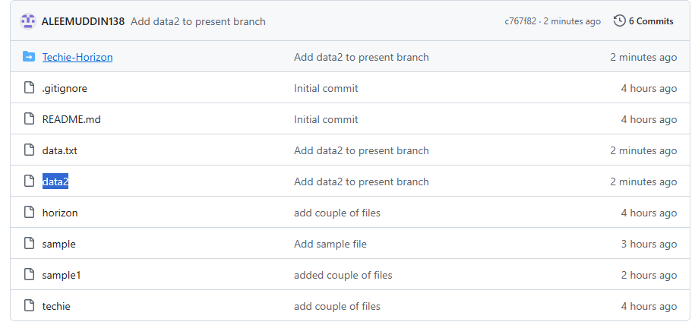

**11) Clone only a branch from github to local.**

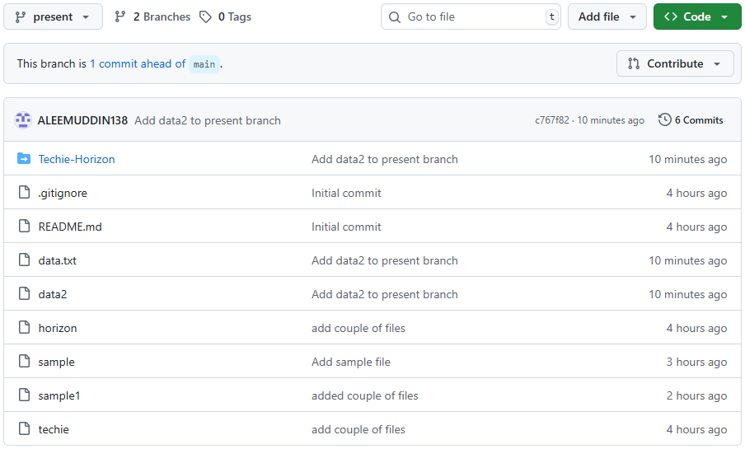

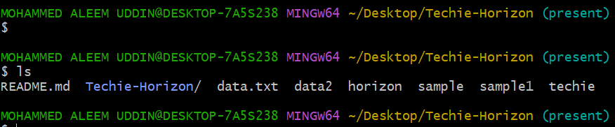

**12) Create a file with all passwords and make that untrackable with git.**

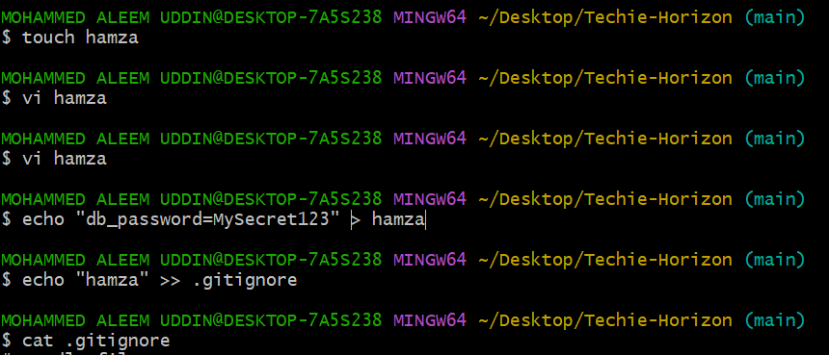

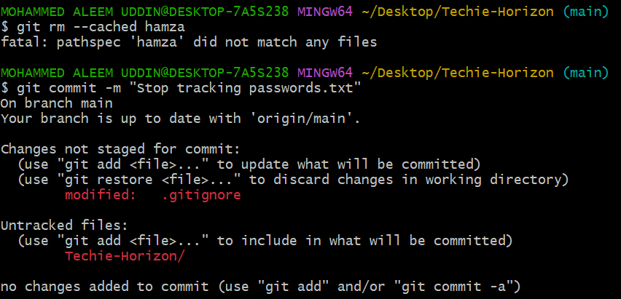

**13) Make a commit and make that commit reset without savings changes.**

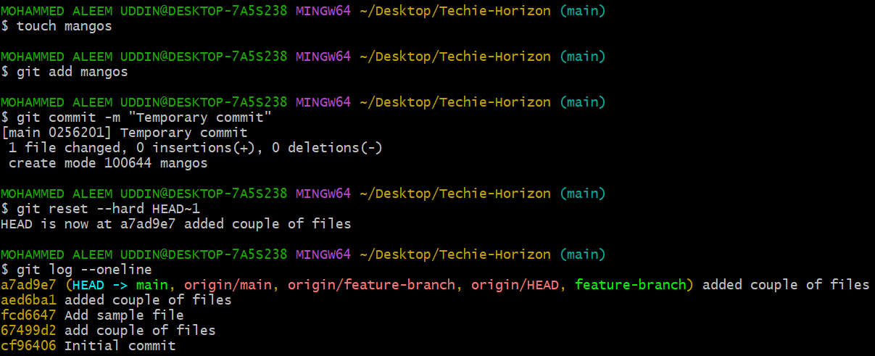

**14) Revert a commited commit to the older version.**

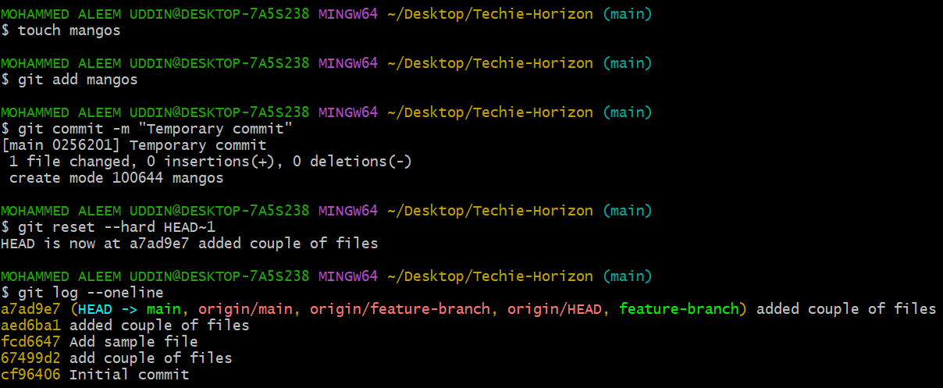

**15) Push a file to stash without savings the changes and work on another file.**

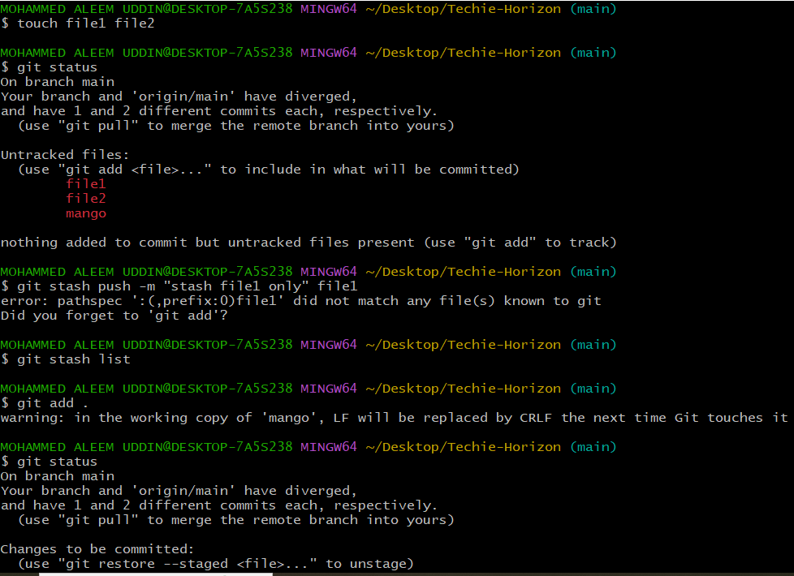

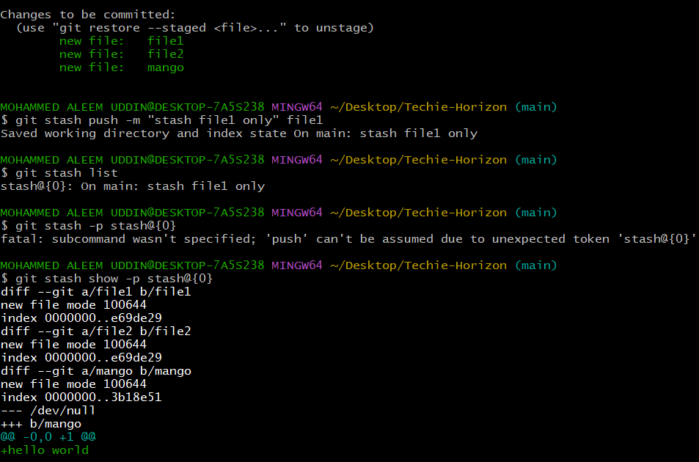

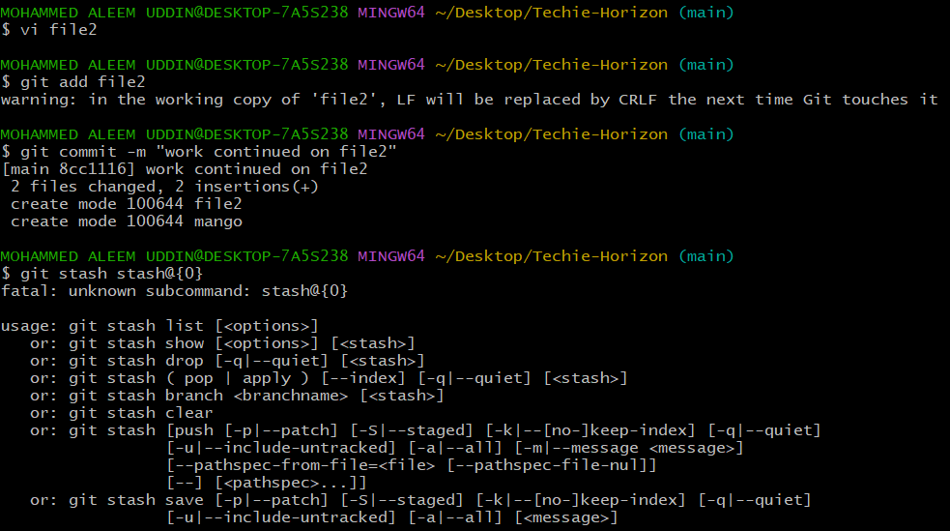

**16) Undo the stash file and start working on that again.**

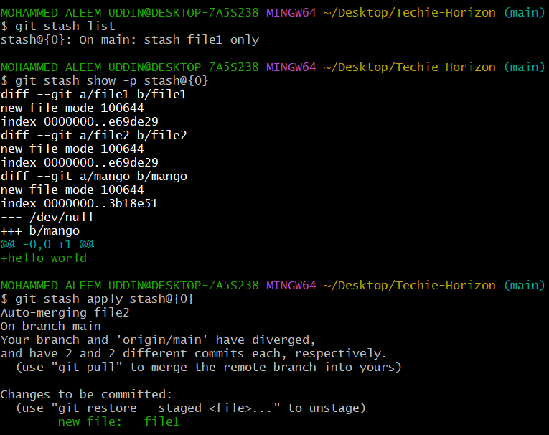

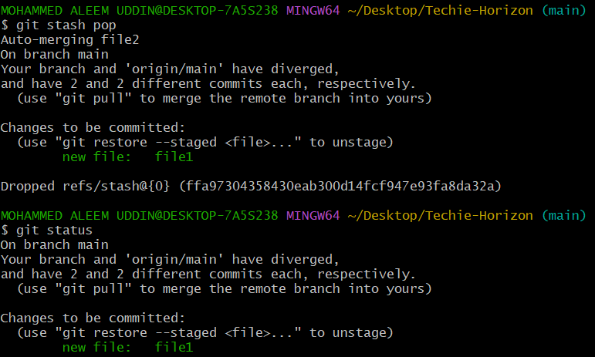

**17) Generate a ssh-keygen and configure into github.**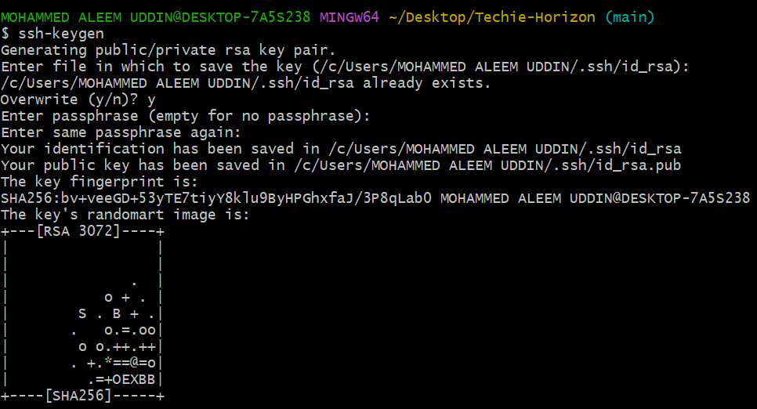

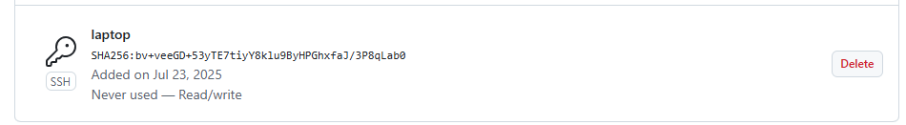

**18) Configure webhooks to github.**

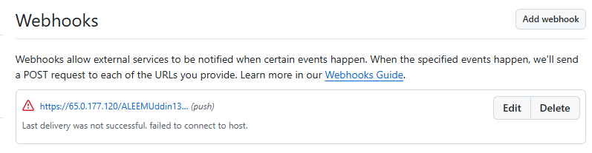

**19) Basic understanding of .git file.**

1) .git is a hidden directory created inside your project when you run:

git init command

2) It contains **everything Git needs** to track versions, branches, commits, configuration, and history.

3) Key components of .git

| File/Folder | Purpose |
| --- | --- |
| config | Git configuration settings (e.g., user name, remotes) |
| HEAD | Points to the current branch (like main or develop) |
| refs/ | Contains references to branches and tags |
| objects/ | Stores all commits, files, trees, blobs (actual content) |
| logs/ | Keeps logs of all reference updates (useful for recovery) |
| index | The staging area – tracks what will go into the next commit |
| hooks/ | Scripts that run on Git events like commit, push, etc. |
| info/ | Exclude patterns like .gitignore, for internal use |
| description | Description used in bare repositories |

**20) Check all the logs of git.**

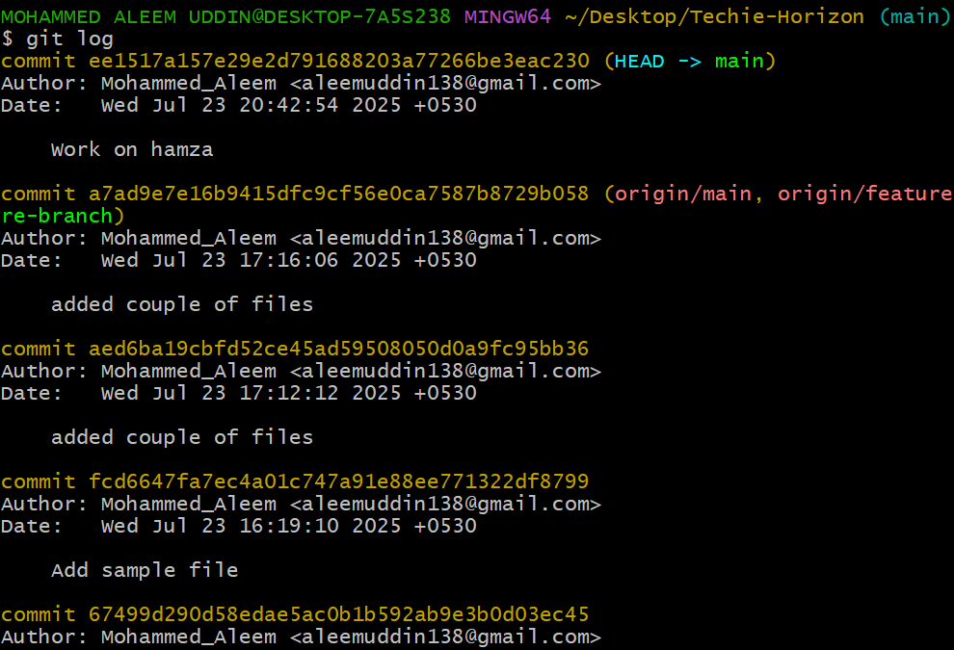

**21) Rename the commit message.**

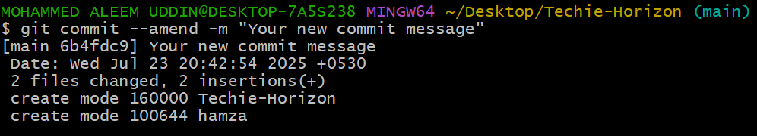

**22) Merge multiple commits into single commit.**

